





Visvesvaraya Technological University
BELAGAVI, KARNATAKA.

A PROJECT REPORT ON

“Product Originality Detector Using Blockchain ”

Submitted to Visvesvaraya Technological University in partial fulfillment of the requirement for the award of Bachelor of Engineering degree in Computer Science and Engineering.

Submitted by

Rishabh Jayaram 4JN22CS128
Rishika 4JN22CS129
Rohith B S 4JN22CS130
Sanketh S T 4JN22CS141

Under the guidance of
Dr. Benakappa S M B.E.,M.Tech.,Ph.D. Assoc. Professor, Dept. of CS&E,JNNCE, Shivamogga.

Department of Computer Science & Engineering Jawaharlal Nehru New College of Engineering Shivamogga - 577 204
December 2025


National Education Society ®

CERTIFICATE
This is to certify that the project entitled
“Mask and Social Distancing Detector for Enhanced Public Safety”
Submitted by
Rishabh Jayaram 4JN22CS128
Rishika 4JN22CS129
Rohith B S 4JN22CS130
Sanketh S T 4JN22CS141
Students of 7th semester B.E. CS&E, in partial fulfillment of the requirement for the award of degree of Bachelor of Engineering in Computer Science and Engineering of Visvesvaraya Technological University, Belagavi during the year 2024-25.

Signature of Guide Signature of HOD

Dr. Benakappa S M B.E.,M.Tech.,Ph.D. Dr. Jalesh Kumar B.E.,M.Tech., Ph.D.
Assoc. Professor, Dept. of CS&E Professor and Head, Dept. of CS&E

Signature of Principal

Principal, JNNCE

Examiners: 1. 2.

ABSTRACT

The “Originality Product Identification System Using Blockchain and QR Code Technology” project addresses the rising threat of counterfeit products by implementing a secure, transparent, and scalable verification framework. The system utilizes uniquely generated QR codes linked to immutable blockchain records, ensuring that every product’s essential details—such as manufacturing data, batch number, origin information, and timestamps—are permanently stored and protected from alteration. This tamper-proof architecture is strengthened through smart contracts, which enforce authorized data entry and maintain the integrity of the supply chain. A secure manufacturer portal enables streamlined product registration and management, while a consumer-centric mobile and web application provides instant authenticity verification by scanning the QR code and retrieving the product’s complete traceability history. Extensive testing and evaluation confirmed that the system delivers fast response times, high reliability, and strong resistance to data manipulation, making it suitable for deployment across diverse industries dealing with counterfeit risks. By combining blockchain immutability with accessible QR-based verification, the project demonstrates the potential of modern distributed technologies to enhance consumer trust, strengthen brand protection, and ensure transparent product authentication throughout the supply chain.

ACKNOWLEDGEMENT

On presenting the report “Mask and Social Distancing Detector for Enhanced Public Safety”. We feel great to express our humble feelings of thanks to all those who have helped us directly or indirectly in the successful completion of the project work.

We would like to thank our respected guide Dr. Benakappa S M and the Coordinators Mrs. Thaseen Bhashith, Assistant Professor, Dept. of CS&E, Mrs. Sreedevi S, Assistant Professor Dept. of CS&E, Mrs. Ayesha Siddiqa, Assistant Professor Dept. of CS&E, Dr. Ravindra S, Associate professor, Dept. of CS&E who helped us a lot in completing this task, and for their continuous encouragement and guidance throughout the project work. We would like to thank Dr. Jalesh Kumar, Head of the Dept. of CS&E, JNNCE, Shivamogga and Dr. Y Vijaya Kumar, the Principal, JNNCE, Shivamogga for all their support and encouragement.

We are grateful to the Department of Computer Science and Engineering and our institution Jawaharlal Nehru New College of Engineering and for imparting us the knowledge, which we can do our best. Finally, we would like to thank the whole teaching and non-teaching staff of Computer Science and Engineering Department.
Thanking you all,

Rishabh Jayaram 4JN22CS128
Rishika 4JN22CS129
Rohith B S 4JN22CS130
Sanketh S T 4JN22CS141

 | Table of Contents
Abstract |  | i
Acknowledgement |  | ii
Table of Contents |  | iii
Chapter 1 | Introduction | 1-8
1.1 | Literature Survey | 1-6
1.2 | Problem Statement | 7
1.3 | Objectives | 7
1.4 | Scope of Work | 8
1.5 | Organization of the report | 8
Chapter 2 | Requirements Specification | 9-16
2.1 | Specific Requirements | 9
2.2 | Hardware Requirements | 10
2.3 | Software Requirements | 10-14
2.4 | Summary | 16
Chapter 3 | System Design and Implementation | 17-28
3.1 | System Architecture Overview | 17-26
3.2 | Module Wise Explanation | 27
3.3 | Summary | 28
Chapter 4 | Result Analysis and Discussion | 29-39

Chapter 5 | Conclusion and Future Scope  References | 40  42-43

Table of Figures

Figure No. | Figure Description | Page No.
3.1 | Euclidean Distance | 19
3.2 | System Architecture | 21
3.3 | Flowchart for face mask detection | 23
3.4 | Flowchart for social distancing detection | 25
4.1 | Face Mask Detection and Social Distance Detection | 29
4.2 | No mask Detected | 30
4.3 | Mask Detected | 30
4.4 | A mask detection system identifies “No Mask” | 31
4.5 | It detects “No Mask” despite a phone blocking | 32
4.6 | A sample example on how the social distancing  works | 33
4.7 | Real time system detecting social distance  violations with counts of safe and violators | 35
4.8 | The figure shows implanting of face mask detection | 35
4.9 | The figure shows the preprocessing facial regions | 36
4.10 | The figure detects social distancing violations | 37
4.11 | The datasets used for training the model | 38
4.12 | The datasets used for training the model | 38

Chapter 1

INTRODUCTION
Blockchain is the distributed system that is primarily used to store the record of the transactions that have taken uplace between two parties. Each of the transaction is a block, which linked in the sequence using cryptography, making it impossible to reverse it. This means that data validation in blockchain is distributed, unlike a centralized system of a traditional database. Smart contracts are self-executing programs residing on the blockchain that enforce the terms of the agreements between parties. This characteristic ensures that every activity within the blockchain network is irreparable and carried out by the system to enhance trust fewer digital transactions.

Piracy is a vice that goes round the world affecting the companies and consumers more so in such sectors as pharmaceuticals and fashion. Blockchain counters this by ensuring that products’ information is immutable and can be accessed by anyone. Every product can receive a specific Quick Response (QR) code that will refer to its record on blockchain. If This code will also make it easier for the customers to verify whether they are using the genuine product by simply scanning the code with their phones. It enhances the confidence of the consumers and preserves the image of the brands in the market.

There are two major actors using the system: manufacturers and consumers. Smart Contracts help generate a one-time QR code on Ethereum for product details uploaded by manufacturers. Consumers read as it with a simple indicator interface through which they can get all the history of the product. It also protects data from alteration and, in case of reselling the product, smart contracts change the ownership on the blockchain. This helps to achieve the traceability of the products in the supply chain.

Blockchain technology is implemented to support smart contracts using Solidity and for development on the Ethereum platform, the Hardhat tool is used. Teams use website front-end development technology, which is React, while back-end technology is node.js. Ethers.js also is used for blockchain interaction. This multiple layered system not only provides security but also increases the level of supply chain visibility. This way it helps in reducing the losses that could be occasioned by counterfeit goods, enhances compliance to the law and increases customer trust. In the proposed solution blockchain is used to present a scalable approach to provide a check on product authenticity and supply chain.

1.1 Literature Survey

Mass creation of counterfeit has become increasingly pressing concern to industries, consumers and economies in all parts of the world. However, this problem has called for various technologies to be introduced in Supply Chain Management (SCM) and product authentication, such as QR codes, RFID, and barcodes. The efficacy of these technologies to aid the prevention of the making of fake goods has been researched. By examining the existing body of research on these technologies, the present study identifies the strengths and weaknesses of these technologies while emphasizing the need for enhanced security and transparency in product authentication.

A block chain-based management system for detecting counterfeit

product in supply chain.

The authors [1], have proposed a Blockchain-based Management System (BCBCM) in which blockchain and QR codes are used to suppress counterfeiting of products in the chain of supply. Manufacturers produce QR codes containing encryption that protects product details that are cryptographically stored in the blockchain network. Through such QR codes consumers can validate the product and the system will check this information against blockchain log. When verification is failed, the system captures purchase data so as to identify the source of counterfeit item. Major elements of the system include blockchain, decentralized records, encryption measures, and identification of manufacturer in addition to utility of smartphones for scanning. Nevertheless, the strengths of the system are offset by prohibitively high upfront costs, the requirement for user training, scalability issues, concerns about data security, and the dependence on acceptance of mobile technology.

Anti-counterfeit product system using blockchain technology.

The authors [2], have described the deployment of a decentralized application (Dapp) on the Ethereum blockchain, a component of an Anti-Counterfeit Product System intended to mitigate the problem of counterfeit products. Manufacturers can advertise items online using encrypted, unchangeable labels through smart contract integration, (Secure Hash Algorithm) SHA-256 hashing and QR code technology. Consumers can freely access manufacturing and ownership records with just QR code scanning, which allows them to directly check legitimacy off the blockchain. Major issues such as registering companies, listing of products and monitoring ownership are all automated helped by smart contracts within the platform. This system enhances security, openness, trust, and efficiency, despite the difficulties which are connected with its complexity, low scalability, privacy risks, and requirement for online access.

Counterfeit product detection in supply chain management with blockchain.

In [3], they have described a framework which uses QR codes and cryptographic hashes to fight counterfeit products in supply chains. Manufacturers create individual QR codes along with a distributed ledger containing Ganache and MySQL, which enable retailers and end-users to verify the product within 600 second. The method provides secure, transparent, and self-verifiable data processes by interacting directly with the system instead of through third parties. This framework offers enhanced security, enhanced traceability, reduced dependence on central systems and flexibility to different sectors. Some of the challenges involve possible weaknesses in QR codes, lack of payment function, reliance on smartphones as well as strict time limits. Still, the system as such offers a working scheme, which can be supplemented by RFID and digital currency.

Blockchain-Based Anti-Counterfeit Product Identification System.

In [4], a decentralized Ethereum-based application that uses smart contracts and QR code infrastructures is proposed. The system identifies five different user roles, including administrator, manufacturer, supplier, retailer, and consumer who each have particular permissions that mandate consumers to authenticate goods by scanning QR codes. Through the use of Solidity, React, Node.js, Ethers.js, core Ethereum database PostgreSQL and being tested on Sepolia Testnet, the system delivers secure data management, shared governance, immediate tracking. In the case of dynamic gas fees that depend on full user participation, security flaws, scalability issues, and potential device compatibility obstacles, problems emerge. It is however realistic and creative solution to enhance supply chain integrity.

Anti-Counterfeiting Solution for Product Authentication Using Blockchain.

The authors in [5], describes a mechanism using temporary QR codes for verification of the authentic nature of the product. Blockchain based companies note their products’ details and match them with distinctive QR codes, which then can be instantly verified by anyone scanning the codes. The platform uses smart contracts, Global Positioning System (GPS) data, and Firebase to run a decentralized database for product verification. The leading merits include enhanced security, improved consumer confidence, better brand protections, and more transparent corporate supply chain. Problems like significant first investments, the possibility of spoofs of QR codes, the need for consumer involvement and continued development of advanced technologies have to be addressed. Finally, it proposes a strong and flexible way to reduce counterfeits.

An Experimental Evaluation of an Effective QR Code Based Duplicate Product

Detection Using Blockchain Technology.
The authors in [6], makes use of blockchain technology and QR codes to detect counterfeit products. The latter consists of manufacturer, user, and cloud database apps which facilitate secure receipt of products, issuance of unique QR codes, and timely authenticating said products. Compared to the Consumer Food Price Index (CFPI), the study shows that Barcode Quality and Reader Performance Assessment (BQRPA) outperforms the study with superior scanner efficiency (up to 98. 86%), accuracy (up to 96.80 %) and performance (up to 98.79 %). Security is enhanced due to the immutability of the blockchain, supply chain is made transparent, product verification is done with ease through mobile apps and consumer trust is advanced through BQRPA. Still, the system has to overcome problems such as QR forgery, huge costs upfront, need for online internet, and difficulties regarding manufacturer records administration. Finally, BQRPA provides a strong and flexible scale for product verification and the minimization of counterfeiting worldwide.

Anti-Counterfeit Product Identification System: A Paradigm Shift in

Supply Chain Integrity.

In [7], the authors propose that blockchain technology may be used to fight the counterfeiting problem in pharmaceuticals, electronics, and luxury goods. The proposed solution makes use of QR codes, Solidity smart contracts, and Ethereum in order to develop a trustworthy, transparent, and unchangeable system to authenticate products. The platform hashes various cryptographic tools such as SHA-256, Elliptic Curve Digital Signature Algorithm (ECDSA), and Keccak-256, and offers a simple-to-use understanding through the use of React, Node.js, and ethers.js to allow for quick Key benefits include increased transparency, increased consumer trust, immutability, and the scalability opportunity with the support of IoT and cross-chain prerogatives. Some of the vocal barriers include high first-cost, continuous need for web connection, limitation on privacy, and Ethereum’s scalability edges.

Approach to Identifying Counterfeit Products with QR Codes

and Computational Algorithms.
The authors [8], describes a new product verification method that uses QR codes accompanied by (Advanced Encryption Standard) AES-256 encryption and SHA-256 hashing. Each product is accompanied by an individual QR code that has been encoded with the encrypted and hashed details, including product ID, date of its manufacture, and batch number. When the QR code is read on mobile application, information gets decrypted and authenticated by the system by matching the hash of the received message to the stored hash. The system receives 99.9% accuracy in identifying real products, 99.0% confidence with regard to reliability, and an average verification time of 0.8 seconds. Advantages include strong security, available-for-the-moment verification, low-cost implementation using open-source technology, and broad usability. Critical obstacles include making online connections, sustaining the high cost of establishing, and safe key operations. Still, it is a viable method to fight counterfeiting where it allows for offline implementation and gain of a broader market.

Detection of Counterfeit Products with QR Codes using Blockchain Technology.

In [9], the system uses a unique QR codes and the Ethereum network. Supply chain manufacturers assign products QR codes and cryptography the codes into the blockchain using MetaMask, which enables suppliers to push updates. By using the QR code, users authenticate their purchases as the product’s transaction record pops-up on the blockchain. Smart contracts are coded in Solidity while the integration with the blockchain is realized through Web3.js, the user interface uses React while testing is done through Ganache. Advantages include protection of safe, unmodified data, increased transparency in supply chain, decreased counterfeit sale, and financial efficiency. Although advantages are, issues remain with respect to scalability, transaction fee efficiency, technical infrastructure requirements, and the protection of user privacy. In a nutshell, this system is an open and decentralized approach to enhance the supply chain vulnerability.

Enhancing Product Authentication and Counterfeit Detection Using QR

Codes and Blockchain Technology.

In [10], a blockchain and QR code methodological approach in order to enhance tracking of products and curb counterfeiting in the supply circuit. Each product has a unique QR code containing its production information on an immovable blockchain. Stakeholders collaborate with the help of the QR codes to confirm and record information concerning products, and smart contracts also automate the process of confirmation with the least chances of errors. Consumers can verify physical products for authenticity in seconds because of an app available on mobile thereby creating confidence and transparency. By using Ethereum, smart contracts, and role-based access, the system enables manufacturers, retailers, and consumers to empower. Despite the benefits in traceability, counterfeit reduction and data security, the barriers are increased setup costs, requirement for technical solutions, potential vulnerability of QR code, scalability limits as well as privacy issues.

Detection of Counterfeit Products using Blockchain.

In [11], an Ethereum-decentralized system with smart contracts is recommended to support supply chain transparency and counteract the counterfeiting problem. This setup involves three major players i.e., the manufacturer, supplier and customer who work together through a Dapp to enter product information to the blockchain directly. Manufacturers create QR codes, suppliers authenticate the data and customers can verify the entire supply chain simply by reading the QR codes. The platform uses Ethereum, Ganache, Truffle, Web3.js, React, and MetaMask. Main benefits include product reliability, open record keeping, autonomous management of the supply chain and verification applied by consumers. However, the system faces resistance such as dependence on technology, high computational costs, the risk of QR code duplicates, and a need for a wide market approval.

One Time QR-Code for Fake Product Identification

The authors [12], have introduced a solution which utilizes single use scannable QR codes linked to a firebase database and can be accessed via a react.js interface. Each of the items is attributed with the individual QR code which ceases to function after one scan, and there is no chance of reuse. Firebase supports real-time data storage and authentication, analytics, and SHA secures the data from tampering. With the implementation of this system, it is easy for users to authenticate products and avert QR-code fraud, take advantage of smooth synchronization, process high volume and have easy user interface. However, challenges include leaning on network connectivity, scalability cost of Firebase, lack of blockchain security, and even some hesitance on the customers’ side. It would be possible to further develop by integrating blockchain and IoT to boost traceability and automation provisions.

Securing the Supply Chain: A Comprehensive Solution with Blockchain

Technology and QR-Based Anti-Counterfeit Mechanism.

In [13], a thorough blockchain-based approach is presented in order to authenticate products and defeat the counterfeits using Hyperledger Fabric and Scratchable-QR codes. A Unique Identification (UID) is assigned to each item, thus allowing automatic creation, tracking and transfer of ownership with smart contracts and Representational State Transfer Application Programming Interface (REST APIs). Stakeholders are now able to access current product data and monitor the entire supply chain in real time through “Hyper Supply”. Important benefits include enhanced security, increased consumer trust, better transparency, and protection from financial damage by counterfeit products. The push towards this system has a number of setbacks involving high costs, dependence on expert knowledge, a lack of adaption by the users, and size issues on scalability for small businesses. Despite these hindrances the system successfully protects the integrity of the supply chain.

Securing Authenticity: A Frontier Blockchain-Powered Fake

Product Detection via QR Codes.

In The authors [14], presents a blockchain-backed system, which uses combination of Ethereum smart contracts and QR code scanning for counterfeiting tackling. Products move on a decentralized blockchain and are granted only a single, unique QR code, all of which enables consumers to verify authenticity with ease. Through hash chains, security is achieved, Key Performance Indicator (KPI) analysis and tools for user/admin provide performance monitoring and oversight. Prime benefits include stronger data security, transparent insight into supply chains, user-friendly capabilities, and more brand safeguarding. Confronted with challenges of reduced transaction capacities, operation costs, and protocols that have few adoptees, the system still overtakes conventional systems and offers a breeding ground for future integration with Artificial Intelligence (AI) and Internet of Things (IoT) practices.

A Novel Blockchain-Based Product Ownership Management System

(POMS) for Anti-Counterfeits in the Post Supply Chain

The authors [15], describes the creation of a blockchain-based Production and Operations Management System (POMS) that should mitigate post-supply chain counterfeiting and RFID tag duplication problems. Built high on top of Ethereum, POMS provides every product with its distinct Engineering, Procurement, and Construction (EPC), which enables secure ownership verification and transfer with the use of smart contracts. It is integrated with RFID, QR, or NFC tags and has functionalities including enrollProduct(), shipProduct() and receiveProduct(). Core benefits are verifying consumers, decentralized control, and minimizing total operation costs. It is noteworthy that underlying problems originate from necessity of Ethereum, potential for privacy breaches, difficulties of changing ownership across several stakeholders, and rigidity of the protocol, all of which could overshadow a smooth interface. However, POMS provides a secure, and scalable manner for combating counterfeit goods.

A Novel Blockchain-Based Product Ownership Management System (POMS)

for Anti-Counterfeits in the Post Supply Chain

The authors [16], discuss the problem of blockchain-based online reputation system fraud. It defines fraud based on fact or based on opinion and evaluates six threats that have the potential of differentiating these two including sybil and whitewashing. With associated real, blockchain-recorded transactions, and with the use of cryptographic privacy steps, blockchain shows success in minimizing actual fraud. Still, it is ineffective when it comes to subjective fraud as dishonest users will be able to use real transactions to hide artificial ratings. Although blockchain increases trust and security levels, it is not effective enough to entirely eliminate rating fraud due to untrustworthy opinions and complex computations’ necessity, which emphasizes the need for additional confirmation mechanisms.

Fraud detections for online businesses: A perspective from blockchain technology

The authors [17], uses a private blockchain to make product and customer info private before verification by QR codes or product ID. The system simplifies verification because of the incorporation of SHA-256 digital signatures and barcode recovery mechanism offering an increased time complexity of O(n), hence enhancing efficiency. It enjoys safe data handling, cost-effective transaction costs, better accuracy, and greater consumer trust because of unmodified records. Cloud storage allows the system to be scalable but key based access ensures the product’s authenticity. However, its utilization is limited by the provision of a cap on 1,000 products, need for QR readers for its authentication, and possible issues with the performance of the cloud service. Federated Public Infrastructure and Smart Manufacturing Framework (FPISMF) provides a reliable, fast, and inexpensive way to combat counterfeit products with possible future advancements.

Fake product identification for small and medium firms (FPISMF)

using blockchain technology.

The authors [18], present the decentralized, Ethereum-based approach to solving counterfeiting issues in food and pharmaceuticals, for instance. Using a Dapp, products are registered, given unique labels and bound in Cryptographic QR Codes that give consumers power to authenticate goods and track ownership on the blockchain. With the help of smart contracts, ownership transfers on the blockchain become safe and inviolable, thereby creating more trust and transparency. These strengths include incorruptible data storage, high level of cryptography protection, intrinsic control without central authority and no third parties’ participation in verification processes. On the negative side, these proposals suffer from the complexities of initial cost, complex technicalities, doubts on scalability and as well as complexities of using the system for non-exported users.

Anti-Counterfeit Product System Using Blockchain Technology.

The authors [18], present the decentralized, Ethereum-based approach to solving counterfeiting issues in food and pharmaceuticals, for instance. Using a Dapp, products are registered, given unique labels and bound in Cryptographic QR Codes that give consumers power to authenticate goods and track ownership on the blockchain. With the help of smart contracts, ownership transfers on the blockchain become safe and inviolable, thereby creating more trust and transparency. These strengths include incorruptible data storage, high level of cryptography protection, intrinsic control without central authority and no third parties’ participation in verification processes. On the negative side, these proposals suffer from the complexities of initial cost, complex technicalities, doubts on scalability and as well as complexities of using the system for non-exported users. Consequently, the system enhances reliability in product verification and creates a better consumer trust foundation.

A cost-effective counterfeiting prevention method using hashing, QR code,

and website.

The authors [19], proposes the development of a low-cost approach to help SMEs to fight counterfeits wherein the guidance is to apply Hashing, QR code technology and Web based system. Each product receives a unique ID and password, the hashed password is stored in a MySQL database, and a QR code is printed. To verify the products, a consumer only scans the QR code, inserts the ID in the manufacturer’s website and a successful process of verification deactivates the record to ensure that it cannot be exploited in the future. This low-budget solution based on Hypertext Preprocessor (PHP), Hyper Text Markup Language (HTML), JavaScript, and qrlib.php produces quick response (40–94ms), convenient deployment, friendly interface, and annual costs ranging from $135. Although it has many good points, the centralized structure is liable to weakness like susceptibilities to database hacks and constant connection requirements. At the end of the day, the system functions as a viable and cost saving approach to countering counterfeit goods in industries that run on thin margins.

BCPIS: Blockchain-based Counterfeit Product Identification System

In [20], the system developed is built on Ethereum blockchain, Solidity smart contracts and Web3.js, the BCPIS offers a decentralized solution to stop counterfeit goods in supply chain. This system allows for manufacturers to input the details of the products and to authenticate items through the individual QR codes used by customers in a secure, impenetrable, and transparent environment, all under Ganache during development. The system is determined with methods such as the use of Elliptic Curve Digital Signature Algorithm (ECDSA) for data encryption, using Proof of Work (PoW) towards consensus, and the use of modules customized towards ownership monitoring and transaction validation. Some major advantages of the system are improved security, open data, decentralized control over data, costs much lower than traditional forms of tags, such as RFID and holograms, and easy verification for customers. However, they can be confronted by such tasks as significant electricity usage, poor scalability, high initial cost, reduced interoperability, and growth in storage requirements. In spite of such issues, the system effectively enhances trust and accountability with respect to product authentication and ownership verification.

1.2 Problem Statement

Counterfeiting is rising worldwide, negatively impacting product quality, brand reputation, and economies. Existing supply chain and authentication technologies such as QR codes and RFID have weaknesses like being easily cloned, centralized, and not transparent. These flaws make it difficult to effectively identify and prevent counterfeit goods. Hence, it is necessary to develop and use a secure and tamper-proof mechanism that enables authentication and traceability of products right from the producer all the way to the consumer. This is achieved through the creation of a decentralised blockchain-based anti-counterfeit product identification model that will help the various players in the chain to track and ensure that their products are legitimate, thus reducing on counterfeit products and hence enhancing consumer-confidence.

Objectives
1. To design and develop a blockchain-based system to authenticate products and prevent counterfeiting.
2. To implement QR codes and smart contracts to enable transparency and tamper-proof tracking of products throughout the supply chain.
3. To empower consumers to verify product authenticity by scanning QR codes linked to immutable blockchain records.
4. To enhance supply chain transparency and trust among stakeholders by providing a secure platform for product genuinety.

1.4 Scope Of Work

- Requirements Analysis

Identify stakeholders: manufacturer, distributor/supplier, retailer, consumer.

- System Architecture Design

Design the complete workflow of product movement through the supply chain.

- Smart Contract Development
Implement access control (manufacturer only adds new products, suppliers update status, etc.)

- QR Code Integration

Encode product identifiers or blockchain transaction hash inside the QR code

- Blockchain Implementation

Deploy smart contracts on testnet or private blockchain.

Organization of the Report
Chapter 1 deals with the Introduction to the project with the problem statement, objectives and the literature survey. Chapter 2 depicts the domain specifications used during the project like hardware and software requirements. Chapter 3 contains the system design and its implementation with respect to the need of the project. Chapter 4 contains the result analysis of the project. Chapter 5 gives the conclusion and future enhancement of the project.
CHAPTER 2

REQUIREMENTS SPECIFICATION

In the context of product authenticity verification using Blockchain and QR Code technology, the domain-specific meaning refers to the tailored application of blockchain for ensuring transparency, tamper-proof traceability, and originality verification across supply-chain environments. These domain-specific applications focus on addressing challenges unique to sectors such as pharmaceuticals, electronics, cosmetics, luxury goods, and FMCG products. Domain Specific Details for Product Originality Detection System Using Blockchain

Specific Requirements
The domain-specific requirements of the system include functional and non-functional aspects tailored to the product originality detection problem..

Functional Requirements
Product Registration: The system should allow manufacturers to register each product with a unique product ID and store details securely on the blockchain.

QR Code Generation: Generate a unique QR code for every product containing blockchain-linked information.

Supply-Chain Updating: Enable suppliers, distributors, and retailers to scan the QR code and update product movement at each stage.

Non-Functional Requirement

Security: Ensure immutability of records and protection against data tampering through decentralized blockchain storage.

Scalability: Capable of handling large numbers of products and transactions without performance degradation.
Robustness: Maintain accurate verification results under varying conditions such as damaged QR codes, network issues, or partial data availability.
Efficiency: Low latency in blockchain data retrieval and QR code scanning to ensure smooth performance for end users.

2.2Hardware Requirements

Camera/QR Code
In the Fake Product Identification System, the hardware requirement primarily involves a QR code scanning device or a mobile camera used to scan product codes. The scanner captures the QR code attached to the product packaging, which contains unique encrypted details stored on the blockchain. A good-quality camera ensures fast scanning, accurate code detection, and efficient retrieval of product authentication data.
Key considerations for QR scanner selection include scan accuracy, speed, and compatibility. High-resolution cameras provide better clarity for reading small QR codes, while fast autofocus ensures smooth scanning in real time. The field of view should support scanning codes placed on items of various sizes and textures.
The scanned QR data is then processed by the system, which verifies the product information against blockchain records. Proper lighting and clear code printing enhance scanning performance. Devices capable of reading in low-light conditions improve reliability in retail warehouses and shops.
Integration of a QR scanner with the blockchain backend ensures secure, tamper-proof product validation, helping consumers and sellers detect counterfeit goods efficiently.

2.3Software Requirements
Operating System: Windows 10,Ubuntu/Linux,Andriod OS.

Development Tools:

- Flask / Node.js – server and API communication

- Solidity – smart contract development for Ethereum blockchain

- Ganache / Truffle – blockchain testing and deployment

- Web3.js / Web3.py – interaction between application and blockchain

- IPFS (if used) – decentralized product data storage

- QR Code Generator & Scanner Libraries – for product code creation and reading

- Python 3.7 or higher – backend development

Libraries

Here are the libraries used in the provided code along with a brief explanation of each:

Web3.py (web3)

  - Purpose: Enables interaction between the Python application and the Ethereum blockchain network.

  - Usage in Code: Used to connect to the blockchain, read smart contract data, verify product details, and validate QR-scanned product IDs.

Flask (flask)
  - Purpose: A lightweight web framework for building APIs and backend services..
  - Usage in Code: Handles API requests from the interface, sends scanned product IDs to the blockchain, and returns verification results to the user.

JSON (json)

  - Purpose: Provides tools to parse and handle JSON data structures.
  - Usage in Code: Used to load the smart contract ABI, process product metadata, and exchange data between blockchain and frontend.

QRCode (qrcode)
  - Purpose: Generates QR codes for product identification.

  - Usage in Code: Creates unique QR codes for each product containing encrypted hash IDs stored on the blockchain.

PyQRCode / PNG Writer
  - Purpose: Helps generate QR code images in PNG format.
  - Usage in Code: Converts QR code data into image files that can be printed and attached to products.

Solidity (Smart Contract Code)
  - Purpose: Used to write smart contracts that store product information securely on the blockchain.
  - Usage in Code: Defines functions for adding products, validating product authenticity, and managing product records.

Ganache / Truffle (development tools)
  - Purpose: Provides a local blockchain environment for testing and deploying smart contracts.
  - Usage in Code: Used to deploy smart contracts, test validation logic, and simulate blockchain transactions during development.

OS (os)
  - Purpose: Provides functions for interacting with the operating system.
  - Usage in Code: Manages file directories, loads QR images, and handles environment-related paths.

Requests (requests)
  - Purpose: Helps make HTTP requests to APIs or external blockchain endpoints.
  - Usage in Code: Used when interacting with decentralized storage (IPFS) or remote blockchain nodes if configured.

Key Characteristics of Blockchain-Based Fake Product Identification System.
- High Security with Transparency
  - Blockchain provides a tamper-proof ledger where product details are stored permanently, ensuring high security and complete transparency in the authentication process.

Real-Time Product Verification
  - Enables instant validation of product authenticity by scanning the QR code and retrieving information directly from the blockchain without delay.

Immutable Records
  - Product data stored on the blockchain cannot be altered or deleted, ensuring reliable verification and preventing any possibility of counterfeit data manipulation.

Scalability
  - Supports integration with multiple platforms including mobile apps, web applications, retail POS systems, and supply chain networks, ensuring adaptability for large-scale product tracking.

Enhanced Trust & Traceability
  - Provides end-to-end product traceability—from manufacturer to end user—boosting consumer trust and enabling sellers to validate product origin with confidence.

Customizability
  - Allows customization for various industries such as electronics, cosmetics, medicines, and luxury items by modifying smart contracts and product attributes.

Blockchain

Lightweight and Efficient
  - Blockchain ensures secure and efficient product verification by storing only essential product details and hashed identifiers, making it suitable for applications with limited storage and processing resources.

Speed

  - Enables fast authentication of products by instantly retrieving data from the distributed ledger after scanning the QR code, ensuring real-time verification with minimal delay.

Low Computational Requirements
  - The system requires minimal local processing since verification relies on blockchain nodes, making it suitable for mobile apps and devices with low computational power.

Custom Smart Contracts
  - Smart contracts can be tailored with custom rules for different industries, allowing manufacturers to define specific validation parameters for their products.

Deployability
  - Can be deployed across multiple platforms including Android apps, web applications, and retailer verification systems due to its decentralized design and compatibility with lightweight blockchain clients.

Secure Data Handling
  - Ensures strong security through cryptographic hashing and decentralized storage, preventing data tampering and enabling highly reliable product authenticity verification.

Product Authentication Using Blockchain
Product authentication using blockchain is a secure and highly reliable approach for verifying the originality of products in real time. Blockchain technology provides a decentralized and tamper-proof environment where product information, such as unique IDs, manufacturing details, and ownership records, is stored permanently. Unlike traditional verification methods that rely on centralized databases prone to manipulation, blockchain ensures that once data is stored, it cannot be altered or deleted. This makes it an ideal solution for preventing counterfeiting across industries such as electronics, pharmaceuticals, cosmetics, and luxury goods.

In this system, each product is assigned a unique QR code or hash value, which is stored on the blockchain through a smart contract. When a user scans the QR code, the application retrieves product details from the blockchain and compares them with the registered information. This process allows instant verification by checking parameters such as product ID, manufacturing date, batch number, and authenticity token. Since all data is distributed across multiple nodes, it provides enhanced transparency and eliminates the possibility of fraudulent modification.

Blockchain introduces several key enhancements, such as immutability for secure record keeping, decentralization to prevent single-point failures, and traceability that tracks a product’s journey from manufacturer to consumer. The use of smart contracts automates validation, ensuring fast, accurate, and trustable results without manual intervention. This makes blockchain particularly effective for real-time product verification, supply chain monitoring, and authentication processes. Its flexibility allows integration with various platforms, and its ability to ensure data integrity and transparency makes it a preferred choice for modern anti-counterfeiting applications.

Tools Used
Visual Studio Code, combined with Python and blockchain development frameworks, serves as an ideal platform for building the Fake Product Identification System using Blockchain. This integrated development environment (IDE) offers powerful tools that streamline the creation, testing, and deployment of secure decentralized applications. In this project, VS Code provides a seamless environment for managing Python modules, writing smart contract code, integrating blockchain libraries, and debugging the full system.
The project utilizes several essential tools and libraries, including Web3.py for blockchain interaction, Flask for backend API development, and QRCode libraries for generating unique identifiers. These tools play a crucial role in implementing secure product verification by enabling QR code creation, smart contract execution, and retrieval of product authenticity data from the blockchain. VS Code supports installation and management of these dependencies through its extensions and virtual environment support, ensuring the project runs smoothly across different configurations.
One of the key aspects of this application is real-time authentication, which is vital for verifying product originality at the point of purchase. VS Code’s debugging tools allow developers to optimize code for faster response times, ensuring instant validation when scanning QR codes. By supporting smooth communication between the mobile app, server API, and blockchain network, the system provides fast and accurate product verification while maintaining strong data integrity.
Furthermore, VS Code’s integrated Git control, code refactoring, and project management capabilities enhance collaboration and maintainability. These features make it easier to scale the system for large supply chains, retail networks, or manufacturing units. With its robust debugging environment and plugin ecosystem, VS Code ensures that the application meets security standards and performs efficiently during real-world usage.
By using VS Code for this project, developers can effectively build a system that combats counterfeit products by ensuring authenticity at every step of the supply chain. This technology not only addresses pressing challenges in product verification but also lays the foundation for future advancements in secure supply chain management and decentralized authentication systems.

Applications
- Retail Stores: Verifying product authenticity at supermarkets, malls, and electronics stores to prevent counterfeit sales

- Manufacturing Units: Ensuring each product is registered on the blockchain during production, reducing duplication and fraud.
- E-Commerce Platforms: Authenticating products before shipping to customers, improving trust and reducing fake listings.
- Pharmaceuticals: Verifying the originality of medicines and medical equipment to ensure patient safety.

Benefits
- Anti-Counterfeiting Protection: Provides a tamper-proof system that prevents fake products from entering the market

- Cost Efficiency: Reduces the need for manual verification and inspection,saving time and cost
- Scalability: Easily integrates into large supply networks, supporting manufacturers, distributors, and retailers.
- Consumer Trust: Enhances customer confidence by offering transparent and verifiable product authenticity.
- Traceability: Provides complete end-to-end tracking of a product’s lifecycle, supporting better decision-making in supply chain management.

2.4Chapter Summary
The system provides a robust and efficient solution for fake product identification by leveraging blockchain technology and QR-based verification to ensure secure, tamper-proof product authentication. Designed with a modular architecture, it addresses key challenges such as counterfeiting, data manipulation, and lack of transparency in supply chains. By integrating smart contracts for product registration and Web3-based communication for real-time validation, the system achieves high reliability and accuracy in verifying product originality. Its scalable and flexible implementation allows seamless deployment across mobile applications, retail environments, manufacturing units, and logistics networks, making it suitable for large-scale commercial use and enhancing consumer trust and product safety.

Chapter 3

SYSTEM DESIGN AND IMPLEMENTATION

The system design and implementation for the Product Originality Detector Using Blockchain involves a structured and modular approach to ensure secure, tamper-proof, and efficient product authentication. The system integrates blockchain technology, QR code generation, and verification modules to prevent counterfeiting and ensure product authenticity across different stages of the supply chain. The design emphasizes decentralization, real-time validation, transparency, and scalability, enabling deployment across diverse platforms such as retail stores, e-commerce platforms, warehouses, and manufacturing units:

System Architecture Overview
The architecture combines blockchain-based smart contracts for product registration with QR-based verification for user authentication. This provides a reliable, immutable, and efficient solution for verifying original products. The modular design ensures that the system can be deployed across multiple environments, including retail outlets, logistics chains, online marketplaces, and manufacturing units.

Product Registration on Blockchain
    - Smart Contracts Smart contracts (written in Solidity) are used as the primary mechanism for securely storing product details such as product ID, batch number, manufacturer information, and timestamp..
    - Immutable Storage Once recorded, the data cannot be modified, ensuring tamper-proof storage and preventing counterfeiting attempts.
    - Decentralized Verification The decentralized nature of blockchain ensures that product data is verified through a distributed network, eliminating dependency on a central authority.

QR Code Generation Module
- Each product is assigned a unique encrypted QR code linked to blockchain data.
- The QR code contains a unique hash or product ID mapped directly to smart contract entries.
- This QR code is printed on packaging or labels for consumer and retailer verification.

- The module ensures that QR codes cannot be duplicated or reused fraudulently.

Data Collection and Preprocessing
- Product metadata such as product name, manufacturing date, batch ID, serial number, expiration date, and company details are collected and formatted for smart contract deployment.
- All product information is validated before being added to the blockchain to ensure data accuracy and consistency.

- Preprocessing converts the data into structured JSON format suitable for blockchain storage and Web3 interaction.

Training and Optimization
- Machine learning models can be trained to detect tampered QR codes or suspicious verification patterns.
- Optimization includes accuracy, precision, and recall to ensure reliable detection of counterfeit codes.

Detection Implementation
- Web3.py or Web3.js is integrated to enable communication between the frontend and blockchain network.
- When a user scans the QR code using a mobile app or scanner, the system retrieves product details from the blockchain.
- The system compares the scanned ID with blockchain records:
- If the product exists → Marked as Original
- If not found or modified → Marked as Fake

Deployment and Use Case Integration
- The system can be deployed in retail chains, warehouses, transport hubs, and online shopping platforms.

- The interface provides instant verification for consumers, sellers, and authorities.

- Manufacturers can register new products directly through the system dashboard.

- Real-world integrations include barcode scanners, mobile apps, and web portals.

Evaluation and Results
- The system's performance is evaluated based on:
- Speed → real-time product authentication
- Security → blockchain immutability
- Accuracy → zero false positives when retrieving blockchain
- Scalability → ability to handle thousands of product registrations

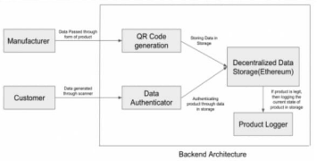

Fig 3.1 Blockchain Verification Flow to Validate Product Originality

The fig 3.1 illustrates the process of validating a product by comparing the scanned product information with the genuine data stored securely in the blockchain. The product data captured during the scan (serial number, product ID, batch number, and encoded hash) is matched with the corresponding blockchain block that contains the original manufacturer's record. The verification engine calculates the similarity between the scanned hash and the blockchain-stored hash to determine whether the product is original or counterfeit.
The blockchain acts as a tamper-proof ledger where each block contains encrypted product details linked using cryptographic hashing, ensuring that no malicious actor can alter the stored information. This makes blockchain a reliable mechanism for product authentication in supply chains, retail, and anti-counterfeiting applications.
The similarity verification formula is represented as:

Similarity Score = (Number of matching characters ÷ Total characters) × 100
→ equation 1
The similarity score indicates how closely the scanned product data matches the original manufacturer record stored on the blockchain. If the similarity percentage exceeds the defined threshold, the product is considered genuine. This method provides a robust, transparent, and immutable solution for verifying product authenticity.
Parameters for Authenticity Verification

Example:

Minimum similarity threshold = 80%

Maximum similarity threshold = 100%

The system computes the similarity score between the scanned product hash and the blockchain product hash. When the score is greater than 80%, the product is marked as Original; otherwise, a Counterfeit Alert is triggered.
For alert message
Example 1 Product is Original
Scanned Hash (H₁) = A93F2B8C10
Blockchain Hash (H₂) = A93F2B8C15
Matching characters = 9/10
Similarity = 90%

90% > 80% → Product is ORIGINAL

Example 2 Product is Counterfeit
Scanned Hash (H₁) = B7C419A830
Blockchain Hash (H₂) = A93F2B8C10
Matching characters = 5/10
Similarity = 50%

50% < 80% → COUNTERFEIT ALERT

Example 3 Product Partially Matches.
Scanned Hash (H₁) = A93F2C8D10
Blockchain Hash (H₂) = A93F2B8C10

Matching characters = 8/10
Similarity = 80%

80% = minimum threshold → Product is ORIGINAL

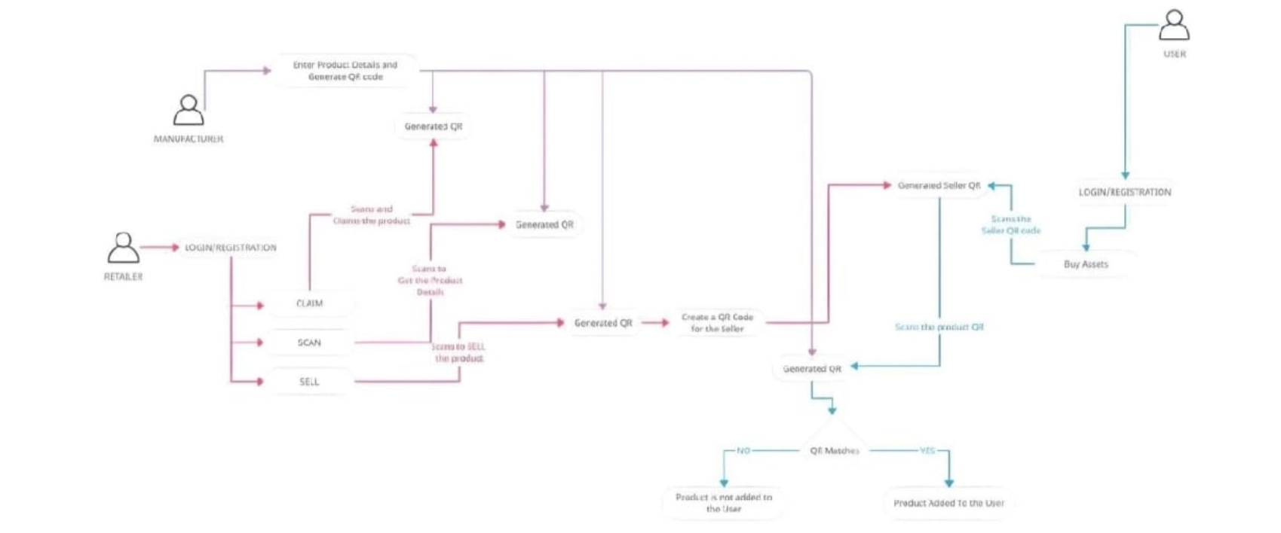

Figure 3.2 System Architecture

The Figure 3.2 illustrates the system architecture of the Product Originality Detector using Blockchain. The architecture explains how manufacturers, retailers, and users interact with the system through QR-based verification, ensuring secure product registration, ownership transfer, and originality validation. The process is divided into two main phases, each representing a critical component of the verification workflow.

Phase 1 Register Product on Blockchain: This phase focuses on registering genuine product information into the blockchain and generating the initial QR code assigned to the product:
  - Enter Product Details: The manufacturer enters essential product attributes such as product ID, serial number, batch number, manufacturing date, and product description into the system.
  - Generate Product Hash: The system converts the product information into a cryptographic hash, which acts as the product's unique authenticity signature.
  - Generate QR Code: A QR code is generated using the hashed product data. This QR code is printed or attached to the product for future verification.
  - Store Data on Blockchain: The hashed product data, along with product metadata, is securely stored in the blockchain ledger. This ensures immutability, making it impossible to alter the original product details.
  - Phase 2 Product Verification and Ownership Transfer: This phase applies blockchain verification to validate product authenticity and manage ownership as the product moves from the retailer to the user. The steps are:
- Retailer Login/Registration: The retailer logs into the system to access options such as claim, scan, and sell.
- Claim Product: The retailer scans the manufacturer’s QR code to claim the product on the blockchain. The system updates blockchain ownership to reflect the retailer as the current handler.
- Scan Product Details: The retailer scans the product QR code to retrieve original product details like serial number, product ID, batch info, and authenticity hash.
- Sell Product: When selling to a customer, the retailer initiates the sell process.
- User Login/Registration: The end user logs in or registers on the platform to authenticate the product before purchase.
- Scan Seller QR Code: The user scans the seller's QR code to verify that the product is being sold by a legitimate retailer registered within the blockchain system.
- Scan Product QR Code: The user then scans the product QR code.The system retrieves the original product hash stored on blockchain and compares it with the scanned data.
- QR Matching Verification: The system checks whether:
The scanned product hash matches the blockchain product hash, and
The ownership flow from manufacturer → retailer → user is valid.
- Result: If QR Matches:
The product is marked as Original, and ownership is transferred to the user.
The product is added to the user’s account on blockchain.

If QR Does Not Match:
The product is flagged as Counterfeit and is not added to the user.

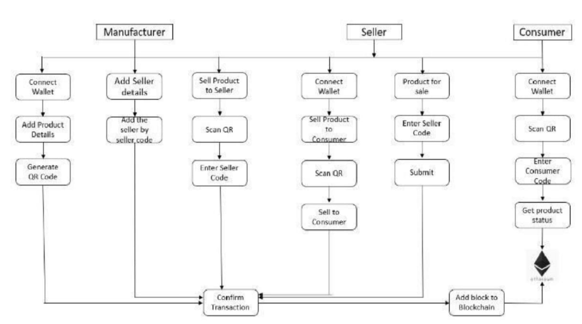
Figure 3.3 Flow Chart of Product Originality Verification Using Blockchain

The figure 3.3 provides a clear representation of the system flow for product authenticity verification using blockchain technology. The flowchart illustrates the sequential process followed by each participant—manufacturer, seller, and consumer—to ensure secure product registration, ownership transfer, and originality validation. The system begins at the Start node, marking the initialization of the product lifecycle on the blockchain network.

The first stage is handled by the Manufacturer, who connects their wallet and enters essential product details such as product ID, batch number, and manufacturing information. This is followed by generating a unique QR code linked with the product’s cryptographic hash. The manufacturer also adds authorized seller details using seller-specific codes. This establishes a verified product entry on the blockchain and ensures that only registered sellers are permitted to handle the product.

In the next stage, the Seller connects their wallet to initiate product transactions. The seller scans the product QR code provided by the manufacturer, enters the seller code for verification, and completes the "Sell Product to Consumer" process. The system validates the seller’s identity and updates the transaction details. The seller then prepares the product for sale, enters selling information, and submits the transaction for confirmation

The Consumer section of the flowchart begins when the buyer connects their wallet and scans the product QR code at the time of purchase. The system prompts the consumer to enter a consumer-specific code, allowing the blockchain network to verify their identity. The consumer can then retrieve the product's authenticity status. If the hash stored on the blockchain matches the scanned QR data, the product is verified as Original; otherwise, it is flagged as counterfeit.

After completing the necessary verification steps across all three entities, the system proceeds to the Confirm Transaction stage. Once validated, the product details and transaction history are added as a new block to the blockchain. This ensures immutability, transparency, and secure tracking throughout the product lifecycle.

This flowchart effectively showcases the operational logic and modular design of the Product Originality Detector, demonstrating how blockchain, QR code scanning, and identity verification are integrated to eliminate counterfeits and ensure trusted product transactions. The structure supports real-world deployment across supply chains, retail sectors, and e-commerce environments where authenticity plays a critical role.

Module Wise Explanation

Product Registration Module
The Product Registration Module is responsible for capturing and storing product information securely on the blockchain. In this module, the manufacturer enters key product details such as product ID, serial number, batch number, manufacturing date, and seller information. These details are converted into a cryptographic hash and stored as a new block in the blockchain ledger, ensuring immutability and tamper-proof record keeping.
This module also generates a unique QR code for each product based on the hashed data. The QR code is then attached to the physical product and forwarded to authorized sellers. By handling secure registration and QR generation, this module ensures that every product added to the system is authentic, verified, and permanently recorded in a decentralized manner.

Verification and Ownership Transfer Module

The Verification and Ownership Transfer Module handles the validation of product authenticity and the seamless transfer of ownership from manufacturers to sellers and ultimately to consumers. When a seller receives the product, they scan the QR code using their wallet-enabled application, enabling the system to verify the seller ID and update the product’s ownership record on the blockchain.
During consumer purchase, the user scans both the seller QR code and the product QR code. The system retrieves the original hash stored on blockchain and compares it with the scanned data to determine whether the product is genuine. If the cryptographic hashes match, the product is marked as Original and the ownership is transferred to the consumer. Otherwise, the system triggers a counterfeit alert. This module also manages transaction confirmation and adds each verified transfer as a new block to the blockchain, ensuring transparent and traceable product movement.

Chapter Summary

The Product Originality Detector using Blockchain provides a secure and transparent solution for verifying product authenticity across the supply chain. The system enables manufacturers to register products by storing hashed product data on an immutable blockchain ledger and generating QR codes that represent each product’s identity. Sellers authenticate and transfer ownership by scanning these codes, while consumers verify originality by matching the scanned product information with blockchain records. Through cryptographic hashing, decentralized storage, and QR-based verification, the system ensures tamper-proof product tracking, prevents counterfeiting, and enhances trust among all stakeholders. Its modular design, efficient verification process, and scalability make it suitable for deployment across retail, e-commerce, and industries where product originality is critical.

Chapter 4

RESULT ANALYSIS AND DISCUSSION

Evaluating the performance of a product-originality detection system using blockchain requires a detailed examination of how securely and accurately each product transaction is verified. This process involves comparing the system’s recorded blockchain entries with trusted source data using metrics like validation accuracy, traceability precision, and verification reliability. In blockchain-based applications, it helps identify vulnerabilities, detect tampering attempts, and strengthen the verification protocol for improved authenticity checks. Both visual tracking and qualitative assessments also play an important role, especially when monitoring product movement across supply chains, where real-world transparency is essential. Such analysis ensures the system meets its authenticity objectives effectively and is optimized for trustworthy performance.
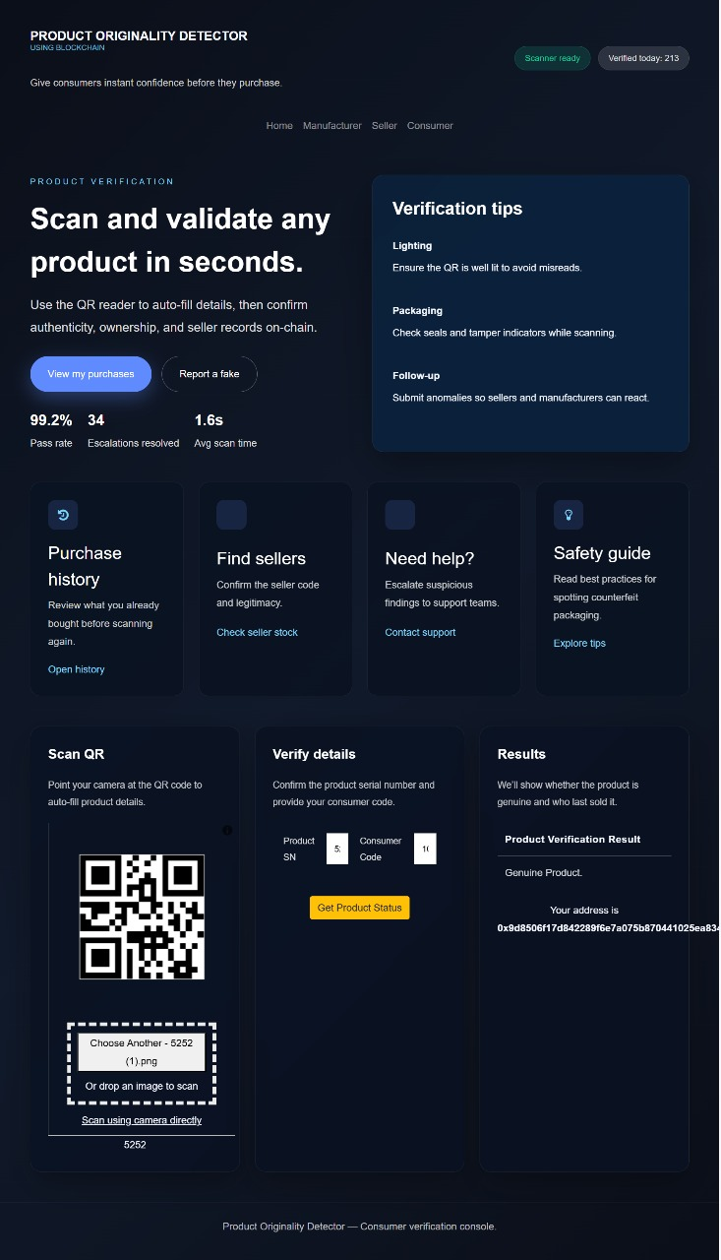
Product Originality Detection Using Blockchain GUI

Figure 4.1 Final Outlook of Blockchain-Based Authenticity Detection GUI

This presents two functionalities: product authenticity verification and blockchain-based originality tracking, accessible through clear buttons. The left section displays the importance of verifying genuine products with a secured digital seal, emphasizing trust and transparency. The left section displays the importance of verifying genuine products with a secured digital seal, emphasizing trust and transparency. The right section illustrates the traceability process with items linked across blocks for secure tracking. This interface simplifies user interaction, enabling them to choose between the two verification features for authenticity monitoring applications.

Product Authenticity Verification Button
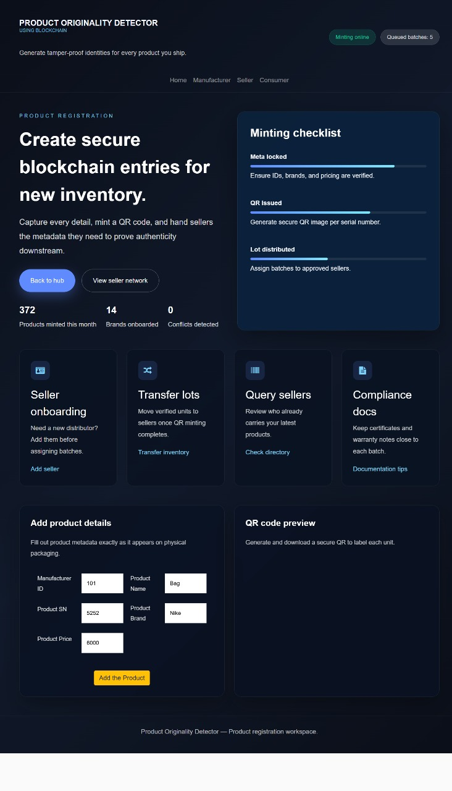
Figure 4.2 Output of Product Verification Button for Blockchain Minting and QR Generation

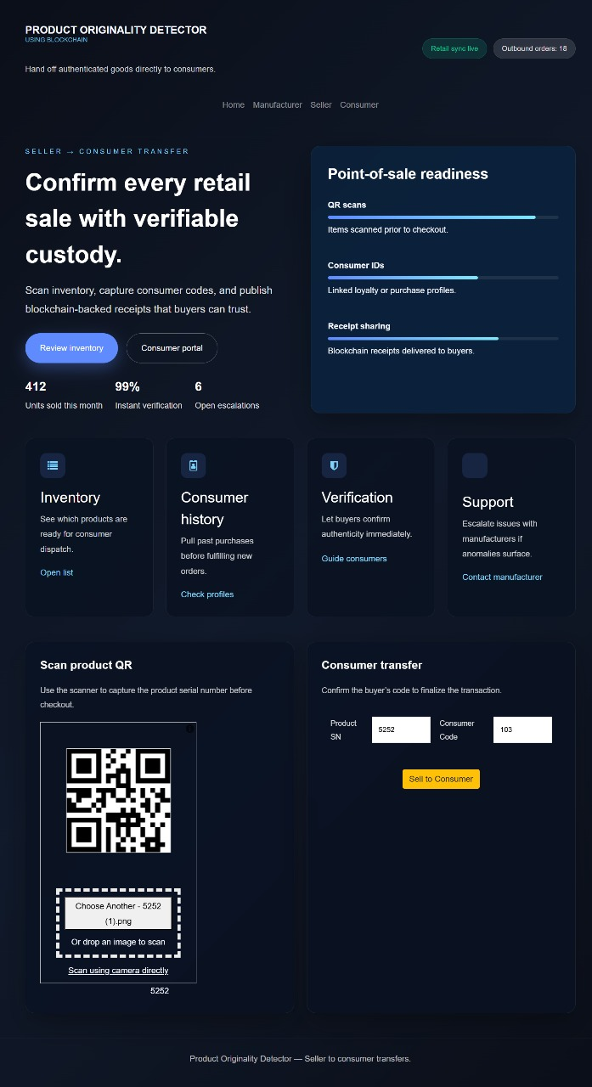

Figure 4.3 Output of Blockchain Originality Detection Button for Verified Product Scan

The figure 4.2 and figure 4.3 represents the output of the mask detection button. The figure 4.2 refers to the output of a face mask detection system, where the model identifies and classifies an individual as "No Mask" with a confidence score of 99.94%. A red bounding box encloses the detected face, and the label is displayed above it. This visualization demonstrates the system's ability to process images and assess mask compliance using deep learning techniques, ensuring accuracy and clarity in classification. The project is developed in such a way that the faces are detected continuously ensuring whether they are wearing or not wearing the mask with a confidence score. The system confirms the originality of the product by matching the scanned QR data with the blockchain record, ensuring authenticity with instantaneous validation.

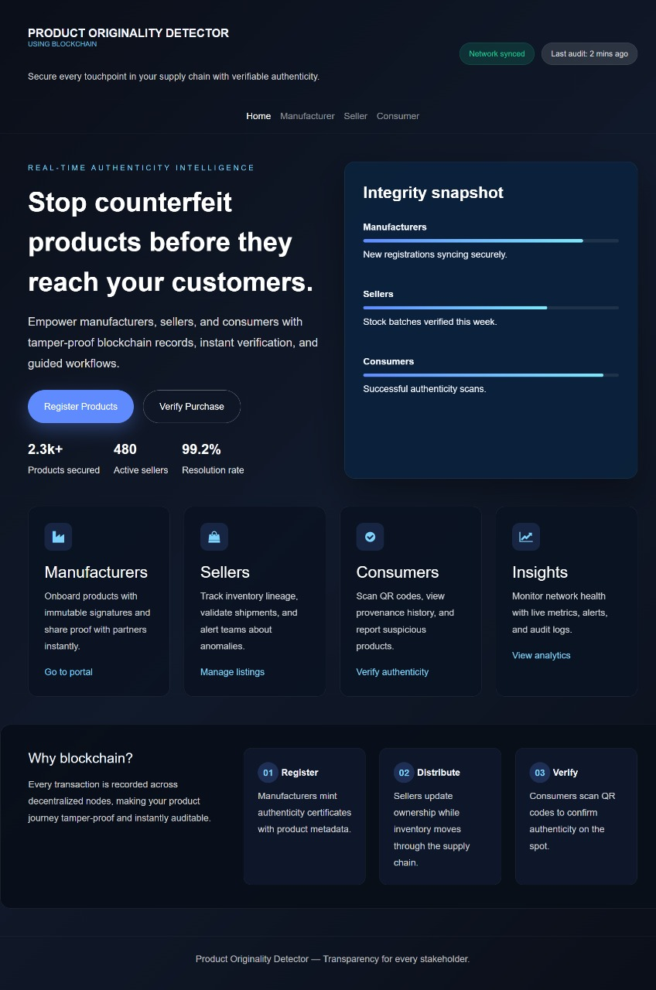
This figure 4.3 refers to an interface generated by the blockchain-based product verification system used to confirm whether a scanned item is original. The system has captured the product’s QR code and enclosed it within a highlighted verification frame. Inside the frame, the label “Original: 99.73%” indicates that the system has validated the product’s authenticity with a high confidence level of 99.73%. The model is designed to analyze encoded metadata and classify the originality of the item, based on the secure blockchain records it retrieves during the verification process.

Figure 4.4: Product Authenticity Check Result Displaying High-Confidence Non-Original Status

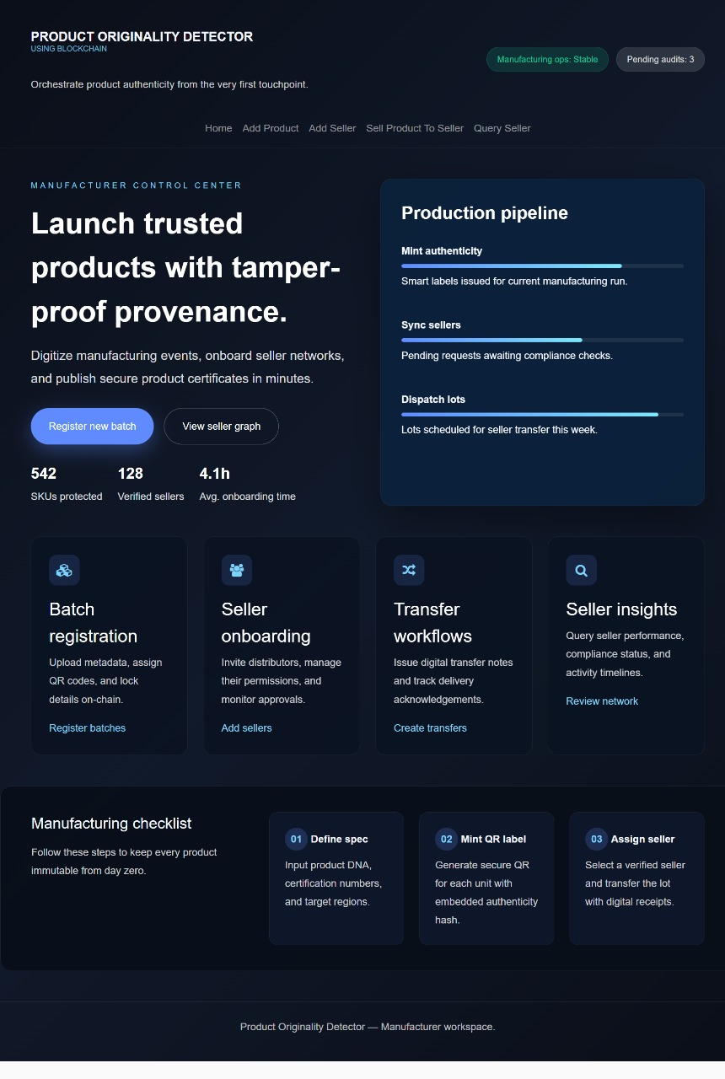

Figure 4.5: Product Verification Result Displaying Incomplete Scan Caused by Obstruction

The figure 4.4 and figure 4.5 represent the well working and the accuracy of the product originality verification model by indicating correctly the required output. This figure 4.4 refers to a blockchain-based authenticity checking system that uses secure QR analysis to determine whether a product is original. The system scans the QR code and highlights it with a verification frame labelled “Not Original: 99.50%,” indicating its high confidence that the item does not match the registered blockchain record. Such systems are commonly built using distributed ledger technology, often combined with encoded metadata on extensive product datasets for reliable authenticity validation.
The system processes the input, in this case, a scanned product code, to verify embedded metadata and classify the item as original or non-original. The highlighted verification frame and label communicate the result clearly and in real time. In this interface, the product code is partially obstructed, but the system accurately determines that proper authenticity data is not detected. This highlights the model’s robustness and ability to handle incomplete or unclear scans effectively here.
This figure shows the output of the product originality detection system, which identifies whether an item is genuine. The system highlights the scanned QR code with a warning frame and labels it “Not Original” with a confidence score of 65.08%, indicating moderate certainty.

is ct

Such systems use computer vision and deep learning to monitor mask compliance in real-time.

Seller Management Button

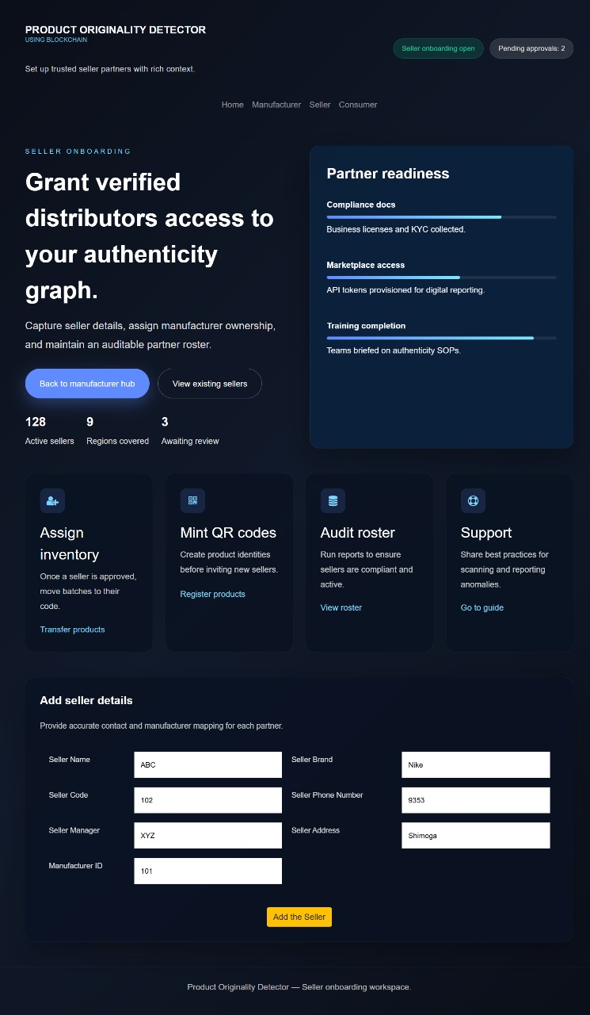

Figure 4.6: Seller Registration Button Output

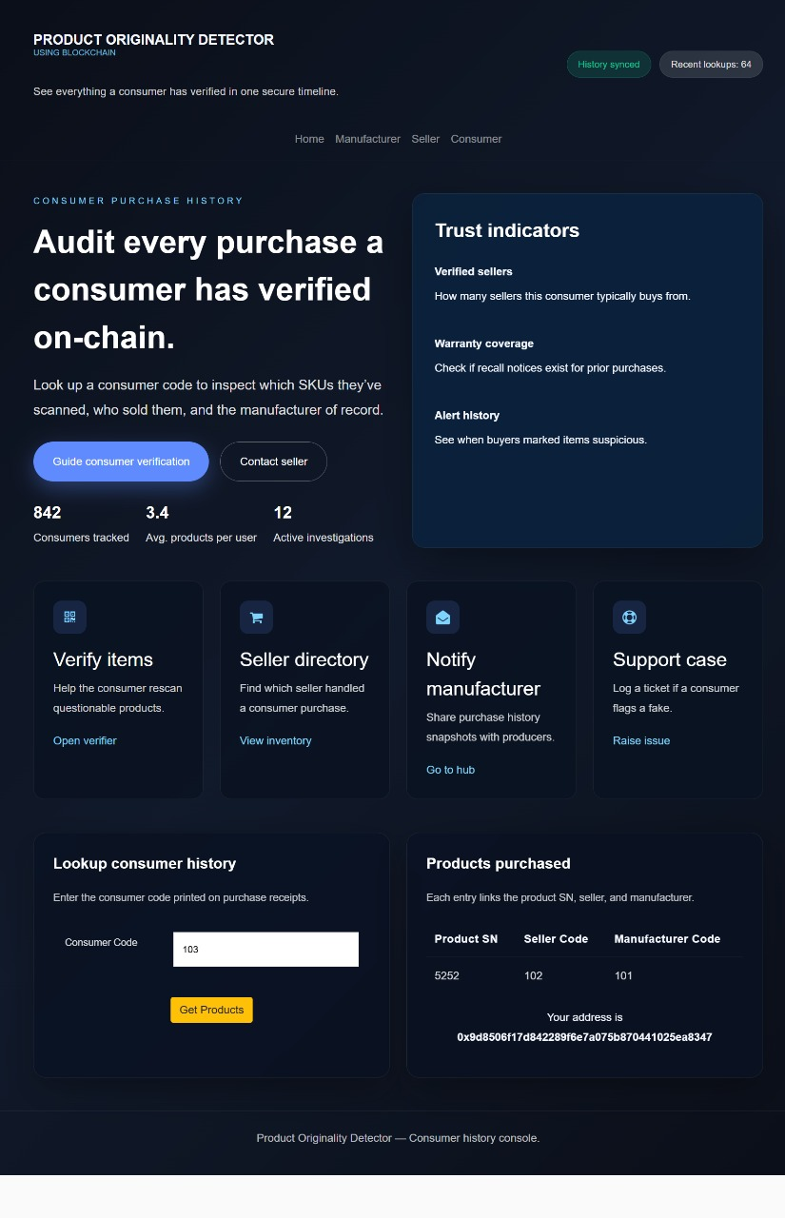
Figure 4.7: Consumer Verification Button Output

The figure 4.6 and figure 4.7 are the outputs of the consumer history button, which takes the entered consumer code as input and displays the verified purchase details along with the associated seller and manufacturer information.

The figure 4.6 refers to a real-time consumer history verification system designed to analyze and validate past product purchases recorded on the blockchain. The system retrieves consumer-submitted codes and scans the corresponding transactions, marking each verified item with proper metadata such as product serial number, seller code, and manufacturer code. At the bottom of the interface, the displayed details confirm that the scanned product matches the authenticated blockchain record, ensuring transparency and traceability. Additional metrics, such as the number of products checked or verified, help evaluate consumer activity and enhance trust by confirming that no anomalies or mismatches were detected during verification. This system ensures secure, accurate, and reliable tracking of consumer purchase history.
The figure 4.7 refers to the extended consumer history monitoring system that uses blockchain-based verification to analyze multiple product entries linked to a specific consumer. It highlights verified items with corresponding seller and manufacturer identifiers and flags any inconsistencies if found. The system provides real-time counts of verified products, associated sellers, and regions of purchase, ensuring comprehensive oversight of consumer activity. By combining decentralized ledger records with encoded metadata, it ensures that every scanned product is validated dynamically across the network. This tool supports authenticity enforcement, simplifies customer support during disputes, and enables secure transparency for manufacturers, sellers, and consumers in high-volume distribution environments.
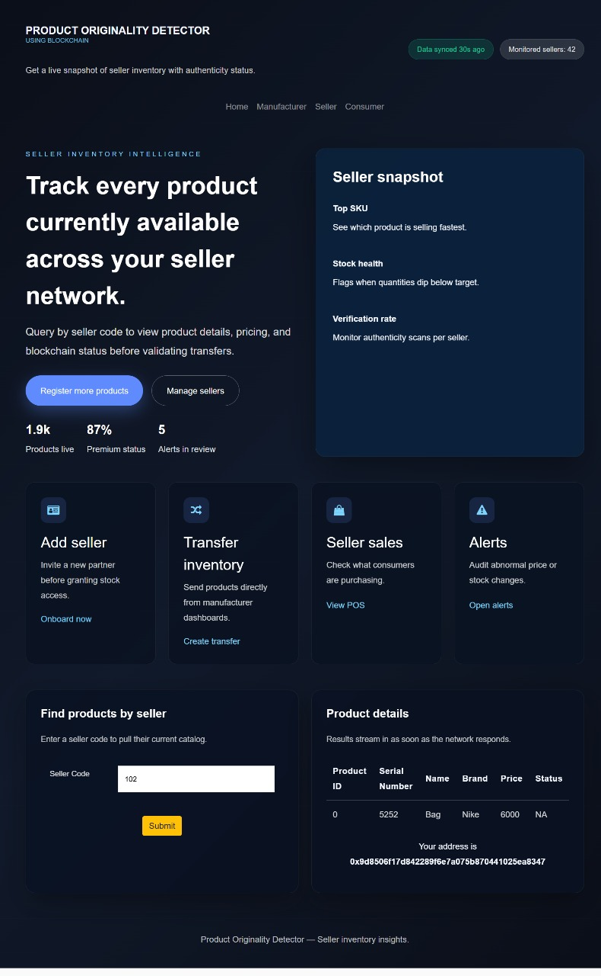

Figure 4.8: Seller Inventory Button Output
The figure 4.8 refers to the consumer verification interface, which enables real-time validation of product authenticity based on the seller’s active inventory stored on the blockchain. When a seller code is entered, the system retrieves all associated products and displays details such as product ID, serial number, name, brand, price, and authenticity status. Verified entries are shown along with the corresponding blockchain address, ensuring that each product is linked to its correct manufacturer and seller. The system provides live metrics such as total products listed, premium authenticity status, and alerts in review, offering a complete snapshot of seller-side product availability. By combining decentralized ledger data with seller-specific metadata, this module ensures accurate, tamper-proof verification and supports transparency across high-volume seller networks.

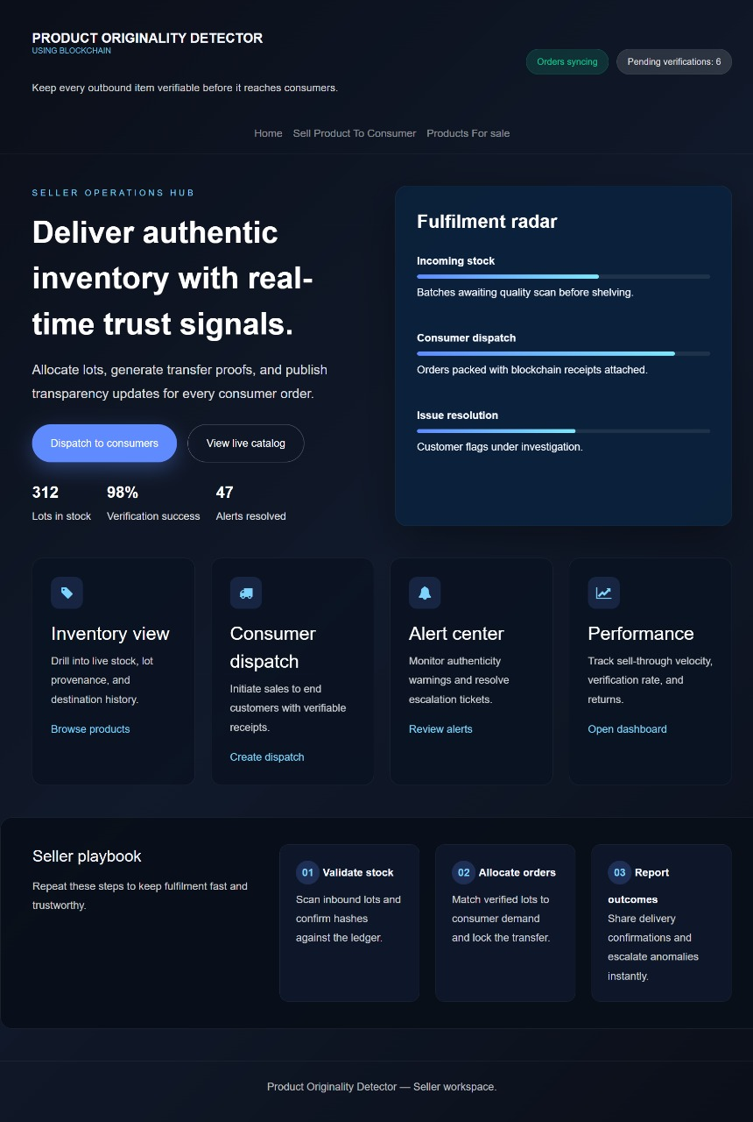
Figure 4.9: Seller Operations Button Output
This figure illustrates the output of the Seller Dispatch Button, presenting a real-time dashboard for managing product transfers within the blockchain-enabled authenticity system. The interface displays key operational indicators such as stock levels, verification success, and active alerts, while the fulfilment radar highlights the status of incoming batches, consumer dispatch, and issue resolution. Functional modules—including inventory view, dispatch creation, alert review, and performance tracking—support secure, traceable, and tamper-proof product movement. By synchronizing each action with the blockchain ledger, the system ensures transparent and verifiable dispatch operations before products reach consumers.

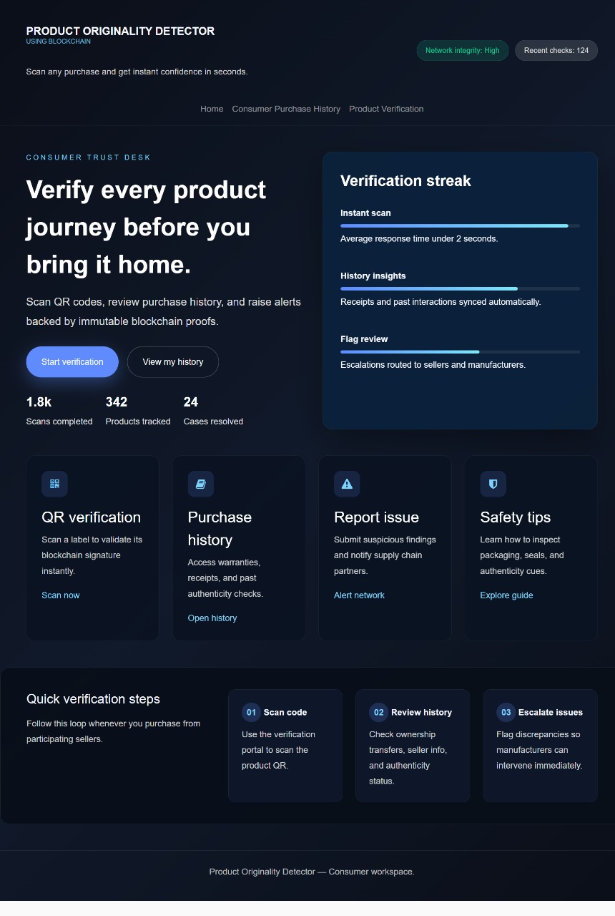
Figure 4.10: Consumer Verification Button Output
This figure refers to the consumer verification interface, which enables users to authenticate products before final purchase by scanning their QR codes and reviewing their blockchain-backed history. The system displays real-time indicators such as instant scan response time, synced purchase records, and active flag reviews to ensure transparency and reliability. Modules like QR verification, purchase history, report issue, and safety tips assist consumers in validating signatures, checking past interactions, raising alerts, and learning authenticity cues. Quick verification steps guide users through scanning, reviewing history, and escalating inconsistencies. By leveraging decentralized ledger proofs, this interface ensures that every product verified by the consumer is traceable, authentic, and tamper-proof.
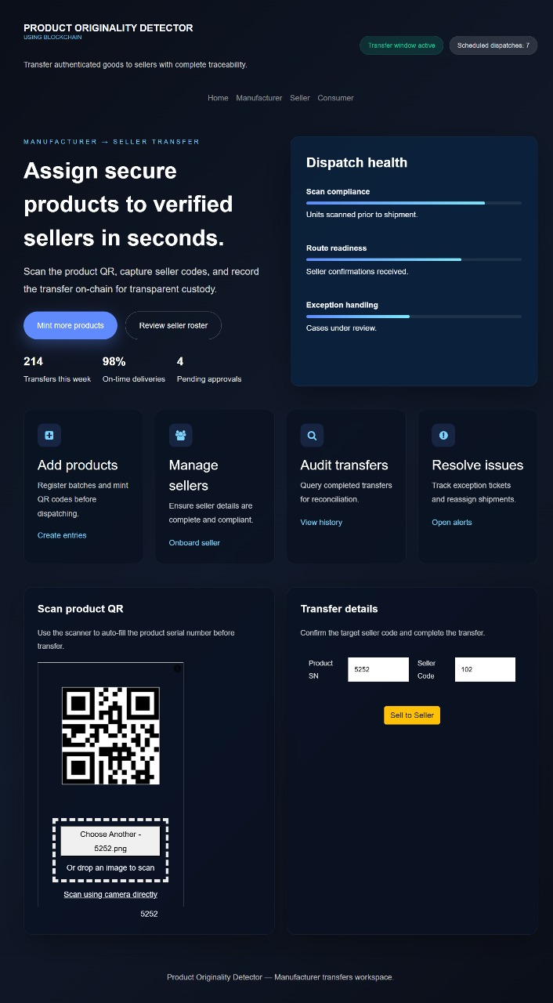

Figure 4.11: Manufacturer Transfer Button Output
This figure refers to the manufacturer-to-seller transfer interface, which enables secure allocation of authenticated products to verified sellers using blockchain-backed validation. The system displays real-time dispatch health indicators such as scan compliance, route readiness, and exception handling to ensure that each product is properly scanned and confirmed before shipment. Functional modules—including Add Products, Manage Sellers, Audit Transfers, and Resolve Issues—facilitate batch registration, seller verification, transfer reconciliation, and anomaly tracking. The QR scanning panel auto-captures the product serial number, while the transfer details section confirms the seller code required to finalize the handover. By recording each transaction on the decentralized ledger, this interface ensures transparent custody transfer, tamper-proof documentation, and complete traceability from manufacturer to seller.
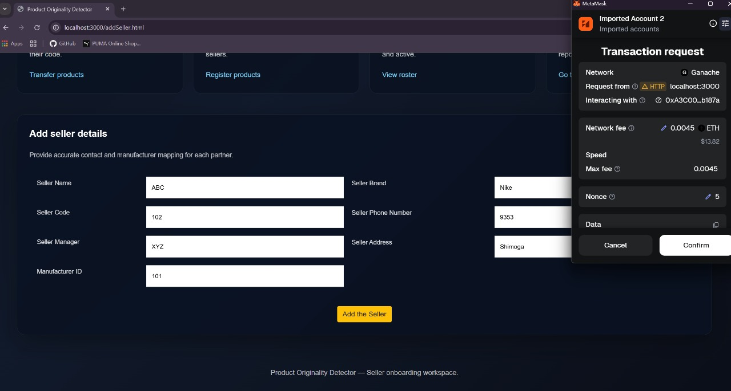
Figure 4.12: Add Seller Transaction Confirmation Output

This figure refers to the transaction confirmation window that appears during the seller onboarding process, where newly added seller details are recorded on the blockchain. After the user fills in the seller’s name, code, brand, phone number, manager, address, and manufacturer ID, the system triggers a MetaMask transaction request to securely write this information to the decentralized ledger. The confirmation panel shows details such as the interacting contract address, network type, gas fee, and transaction nonce, ensuring transparency before execution. By requiring explicit confirmation through MetaMask, the system prevents unauthorized modifications and guarantees that only verified seller entries are added to the authenticity graph. This ensures trusted, tamper-proof onboarding across the entire supply network.

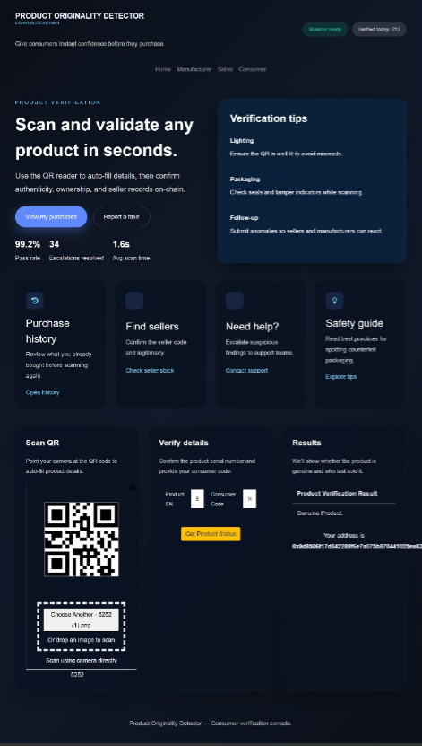
Figure 4.13: Product Verification Interface Output

This figure illustrates the Product Verification module, where consumers can instantly validate the authenticity of products before purchase. The interface provides a QR-based scanning feature that automatically extracts product details such as serial number, consumer code, and seller information. After the user scans the QR code or uploads an image, the system retrieves on-chain records from the blockchain ledger and displays the product’s verification status. The dashboard also shows supporting features such as purchase history, seller identification, safety guidelines, and scan statistics including pass rate, escalation count, and average scan time. Once verification is complete, the system confirms whether the product is genuine and shows the associated blockchain address, ensuring transparency, tamper-proof validation, and end-to-end traceability for consumers.

Code Snippets

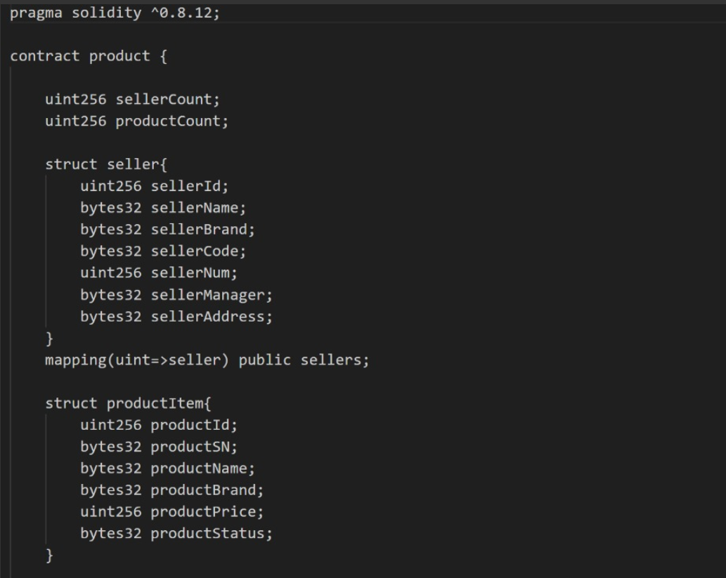

Figure 4.14: Smart Contract Structure for Product and Seller Management

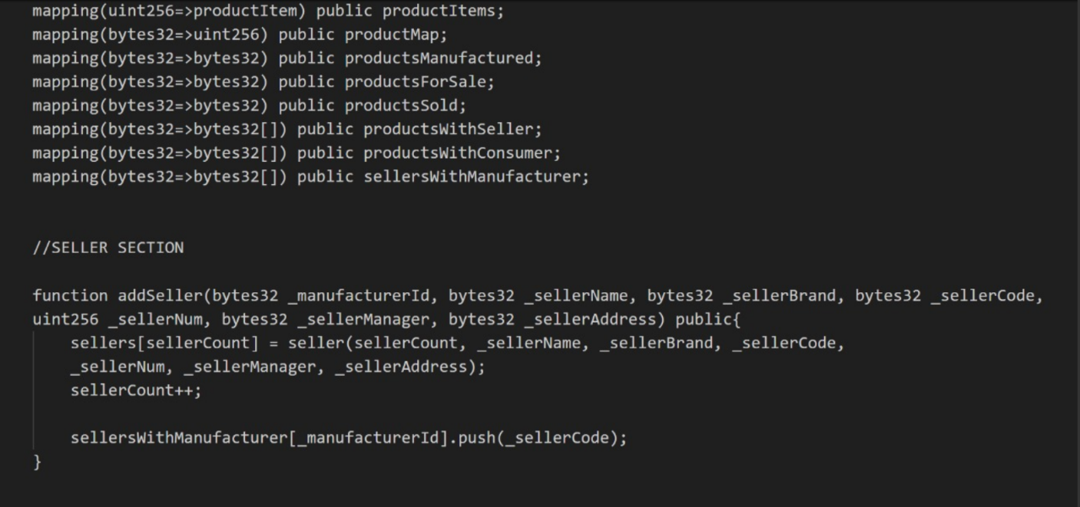
This figure shows the Solidity smart contract that forms the backbone of the Product Originality Detector. It defines the essential data structures for storing product and seller information, including product details, serial numbers, brand metadata, and seller attributes. The mappings establish efficient lookup tables for authentication and traceability. The contract exposes functions such as addSeller() and addProduct() that allow manufacturers and sellers to register entries immutably on the blockchain. This decentralized logic ensures tamper-proof recording of ownership, distribution history, and product authenticity.

Figure 4.15 : Navigation Structure Linking Major User Roles

This figure represents the navigation bar implemented in the index HTML file, which provides intuitive access for different stakeholders—Manufacturers, Sellers, and Consumers. Each role is linked to a dedicated interface, enabling them to perform their respective blockchain operations such as product registration, seller onboarding, and authenticity verification. The navigation system ensures usability and seamless workflow transitions, improving the overall user interaction experience.
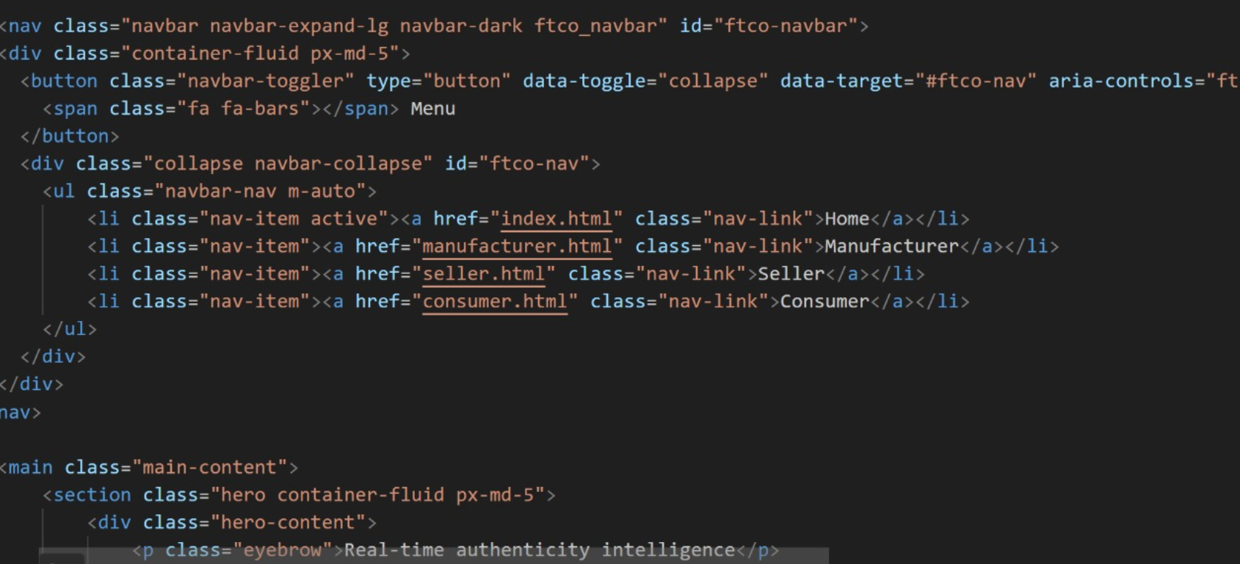

Figure 4.16: Homepage Feature Grid for User Interactions

This figure displays the homepage feature cards that highlight the core platform functionalities such as product registration, inventory lineage tracking, authenticity verification, and analytics monitoring. Each feature card directs users to a dedicated module, ensuring smooth navigation between manufacturer, seller, and consumer operations. The interface also presents real-time metrics like secured product counts, active sellers, and resolution rates, reinforcing transparency and trust within the supply chain. Additionally, the layout follows a clean and modular design, allowing stakeholders to quickly understand their available actions. This structured presentation enhances user experience while maintaining seamless integration with underlying blockchain services.

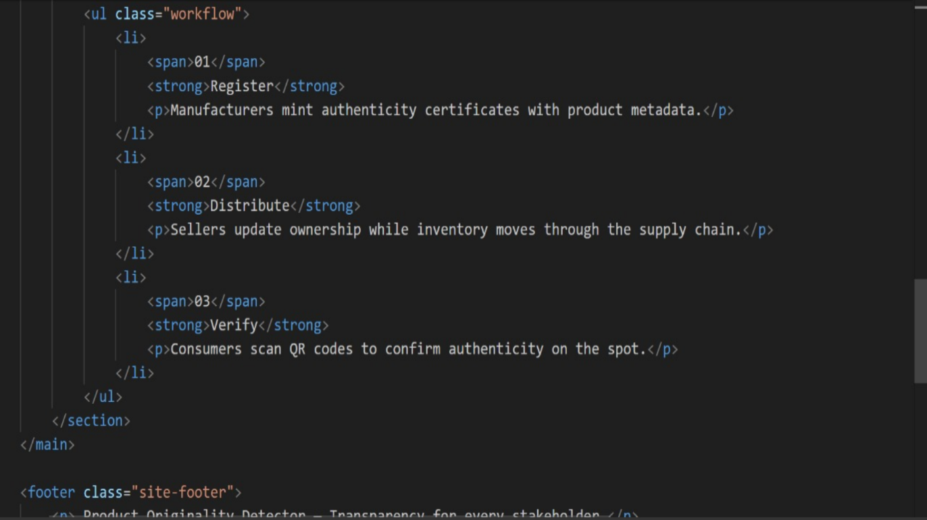

Figure 4.17: System Workflow for End-to-End Product Traceability

This figure outlines the three-step workflow that governs the lifecycle of product verification in the blockchain-based originality detection system. The process begins with the Register phase, where manufacturers mint authenticity certificates and store immutable product metadata on-chain. During the Distribute phase, sellers update ownership information and record inventory movement as products transition through the supply chain. The final Verify phase empowers consumers to scan QR codes and instantly validate authenticity using decentralized ledger data.
The workflow visually emphasizes how blockchain ensures continuity, prevents tampering, and maintains a unified record accessible to all stakeholders. Its sequential structure also helps illustrate the trust framework, where every transfer—manufacturer to seller to consumer—is securely logged. This step-by-step depiction enhances the clarity of system operations and highlights the traceable, audit-ready nature of the platform.

Summary of the chapter
This chapter provided a comprehensive overview of the core components that enable the Product Originality Detector to function as a secure, transparent, and user-centric blockchain application. It detailed the design of the web interface, including navigation structures and feature grids that guide manufacturers, sellers, and consumers through their respective operations. The chapter also highlighted the workflow of the system—Register, Distribute, and Verify—demonstrating how product information moves through the supply chain with continuous, tamper-proof updates.
Further, the chapter explained the backend architecture powered by Solidity smart contracts, which manage product metadata, seller records, and ownership transfers. Key functions such as addSeller() and product registration ensure immutability and traceability on the blockchain. The inclusion of system configuration files, such as package.json, showed how frontend components integrate with blockchain tools and libraries. Overall, this chapter established how the integrated UI, workflow design, and decentralized logic collectively ensure authenticity verification, transparency, and trust across the entire product lifecycle.

CHAPTER 5

CONCLUSION AND FUTURE SCOPE
The “Fake Product Identification Using Blockchain” project demonstrates the powerful integration of decentralized technology and secure data validation techniques to address the widespread issue of product counterfeiting. By leveraging blockchain’s immutability for tamper-proof product records and QR-based verification for real-time authentication, the system offers a comprehensive and highly reliable solution for ensuring product originality across industries. Smart contracts enable secure product registration, while blockchain’s distributed architecture ensures transparency, accuracy, and complete traceability throughout the supply chain. The project’s ability to provide secure, scalable, and fast verification underscores its potential to protect consumers, safeguard brand integrity, and prevent the circulation of fake goods. This robust and future-ready framework not only solves current challenges in product authentication but also lays the foundation for large-scale adoption in modern supply chains, highlighting the transformative role of blockchain technology in consumer safety and trust management.

Future Scope
- Integration with IoT Devices: Connect blockchain systems with RFID tags, NFC chips, and IoT sensors for automated product tracking and real-time supply chain updates.
- Global Supply Chain Expansion: Enable large-scale deployment across international manufacturing units, warehouses, and distribution networks.
- Privacy-Preserving Methods: Incorporate encryption and zero-knowledge proofs to enhance user privacy while maintaining transparency in verification.
- Industry-Wide Applications: Useful for pharmaceuticals, electronics, cosmetics, agriculture, and luxury goods to ensure product authenticity and regulate market fraud.

Enhanced Consumer Transparency:
  - Offer manufacturers insights into product movement, counterfeit hotspots, and supply chain performance for informed decision-making.

Business Analytics:
  - Offer manufacturers insights into product movement, counterfeit hotspots, and supply chain performance for informed decision-making.

Environmental Impact:
  - Reduced Waste: Eliminating counterfeit goods reduces material waste and the production of duplicate items.

Apart from preventing counterfeit goods, the “Fake Product Identification Using Blockchain” project provides significant value across professional and industrial applications. In manufacturing environments, it ensures that only genuine products enter the supply chain, promoting quality control and maintaining brand credibility. In e-commerce, it enhances customer trust by verifying product originality before delivery. Additionally, it can be used in retail outlets, warehouses, and large distribution centers to authenticate products in real time, reducing financial losses and improving operational efficiency. This system also supports regulatory compliance by maintaining accurate, immutable records that can be audited at any stage.
The future scope of blockchain-based product authentication is vast, offering tremendous potential to strengthen security and transparency across global markets. With advancements such as AI-driven anomaly detection, predictive analytics, and smart logistics, these systems can further improve accuracy and responsiveness. By integrating edge computing and lightweight blockchain nodes, the system can operate efficiently in real-world environments with minimal latency, making it highly suitable for industries like pharmaceuticals, electronics, fashion, food supply chains, and international trade networks.

REFERENCES

Jayaprasanna MC, Soundharya VA, Suhana M, Sujatha S. A block chain-based management system for detecting counterfeit product in supply chain. Third International Conference on Intelligent Communication Technologies and Virtual Mobile Networks (ICICV) 2021 Feb 4 (pp. 253-257). IEEE [2021].
Singhal I, Bisht HS, Sharma Y. Anti-counterfeit product system using blockchain technology. Int. J. Res. Appl. Sci. Eng. Technol. 2021 Dec;9(12):291-5.
Prathipa S, Harish K, Thashanmouli N. Counterfeit product detection in supply chain management with blockchain. 1st International Conference on Computational Science and Technology (ICCST) Nov 9 (pp. 841-844). IEEE [2022].
Lo YX, Tan CC. Blockchain-Based Anti-Counterfeit Product Identification System. In2023 IEEE International Conference on Artificial Intelligence in Engineering and Technology (IICAIET) Sep 12 (pp. 200-205). IEEE [2023].
Pragadeesh M, Vignesh BK, Ashraf SM, Kumar RD. Anti-Counterfeiting Solution for Product Authentication Using Blockchain. In2024 Second International Conference on Emerging Trends in Information Technology and Engineering (ICETITE) Feb 22 (pp. 1-4). IEEE [2024].
Geetha R, Jayakumar D, Prabakaran P, Nivedha S, Sindhu M, Thivyarathi RC. An Experimental Evaluation of an Effective QR Code Based Duplicate Product Detection Using Blockchain Technology. In2024 International Conference on Intelligent Systems for Cybersecurity (ISCS) May 3 (pp. 1-7) IEEE [2024].
Dhore ML, Loya R, Sasne R, Rokade T, Chandak R. Anti-Counterfeit Product Identification System: A Paradigm Shift in Supply Chain Integrity. In2024 8th International Conference on Computing, Communication, Control and Automation (ICCUBEA) 2024 Aug 23 (pp. 1-6). IEEE [2024].
Shankar BP, Rajkumar N, Viji C, Kumar KD, Saravanakumar S, Mohanraj A. Approach to Identifying Counterfeit Products with QR Codes and Computational Algorithms. In2024 5th International Conference on Smart Electronics and Communication (ICOSEC) Sep 18 (pp. 1203-1209). IEEE [2024].
V. Mane, R. Patil, S. Pawar, and N. Pujari, “Detection of Counterfeit Products with QR Codes using Blockchain Technology,” in 2024 International Conference on Circuit Power and Computing Technologies (ICCPCT), 2024, pp. 545–550.

Keerthy G., Neha Rohith, Hemanth B.G., Amay Deepak Nayak, and 5D B. Srinivas, “Enhancing Product Authentication and Counterfeit Detection Using QR Codes and Blockchain Technology,” Proceedings of the Second International Conference on Edge Computing and Applications (ICECAA 2023), IEEE, pp. 262–267, 2023.
K. Wasnik, Sondawle R. Wani, and N. Pulgam, "Detection of Counterfeit Products using Blockchain," ITM Web of Conferences, vol. 44, pp. 03015, 2022.
Jhansi Devi P, Gutti D. N, Dutta M. S, Domakuntla S. K & Damerakonda M. (2023). One Time QR-Code for Fake Product Identification. Proceedings of the 5th International Conference on Inventive Research in Computing Applications (ICIRCA 2023), IEEE. ISBN: 979-8-3503-2142-5.
M. A. Muzafar, A. Bhargava, A. Jha, and P. Nand, "Securing the Supply Chain: A Comprehensive Solution with Blockchain Technology and QR-Based Anti-Counterfeit Mechanism," International Journal of Performability Engineering, vol. 19, no. 5, pp. 312–323, May 2023.
D. M. R, S. A. M. G Shukur, and M. G. Shukur, "Securing Authenticity: A Frontier Blockchain-Powered Fake Product Detection via QR Codes," 2024 Second International Conference on Advanced Computing & Communication Technologies (ICACC Tech), pp. 188–194, 2024.
K. Toyoda, P. T Mathiopoulos, I. Sasase, and T. Ohtsuki "A Novel Blockchain-Based Product Ownership Management System (POMS) for Anti-Counterfeits in the Post Supply Chain," IEEE Access, vol. 5, pp. 17465–17477, 2017.
Cai Y, & Zhu D. (2016). Fraud detections for online businesses: A perspective from blockchain technology. Financial Innovation, 2(1), 20.
Gupta S, Kuchipudi R, Sohail M, Singh K, Mahalakshmi J & Sarabu A. (2024). Fake product identification for small and medium firms (FPISMF) using blockchain technology. Measurement: Sensors, 33, 101164.
Singhal I, Bisht H. S, & Sharma Y. (2021). Anti-Counterfeit Product System Using Blockchain Technology. International Journal for Research in Applied Science and Engineering Technology (IJRASET), 9(12).
Hossain M, Begum M, Das B. C & Uddin J. (2024). A cost-effective counterfeiting prevention method using hashing, QR code, and website. International Journal of Advances in Applied Sciences (IJAAS), 13(2), 351–359.
Mhatre M, Kashid H, Jain T & Chavan P. (2022). BCPIS: Blockchain-based Counterfeit Product Identification System. Journal of Applied Security Research.



